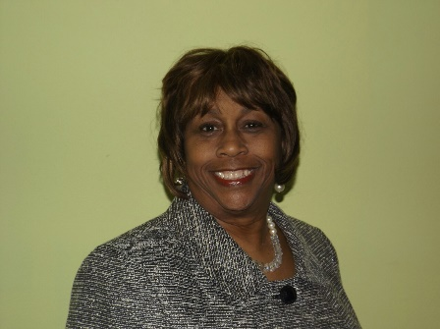

Iota Phi Lambda Sorority, Inc.
Southwestern Region
Business Month Message

Greetings,

I am excited, thrilled and exuberant as I greet you on this most auspicious occasion, “Our Business Month Celebration!” April is the most important month in Iota Phi Lambda Sorority, Inc. where we showcase the many Business Leaders, Youth Entrepreneurs and Community Service Contributors. We take time out to give accolades to these individuals who are making a difference in the world around them.

As we celebrate eighty-five years as the first leading organization committed to magnifying the field of business, professionalism, youth entrepreneurships and sisterhood, we will Move Forward with our goal to do even more through our many programs and projects.

National Business Month, held throughout the United States and the Virgin Island gives us the opportunity to reach out through public audiences, and promote economic empowerment. We are “A United Sisterhood of Business and Professional Women Striving for Economic Empowerment”.

I thank our esteemed founder Lola Mercedes Parker for her leadership and the great legacy we inherited and Trailblazers for committing to the vision. I salute you as honorees and I applaud chapters of the Southwestern Region for giving honor to whom honor is due!

Best Wishes to All,
Linda Hogan Cannon
Southwestern Regional Director

